ALDBROUGH PRIMARY SCHOOL

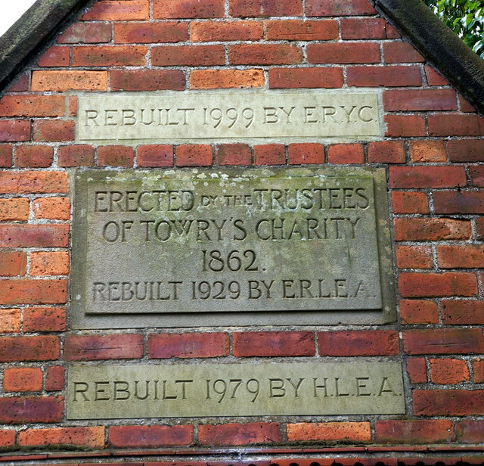

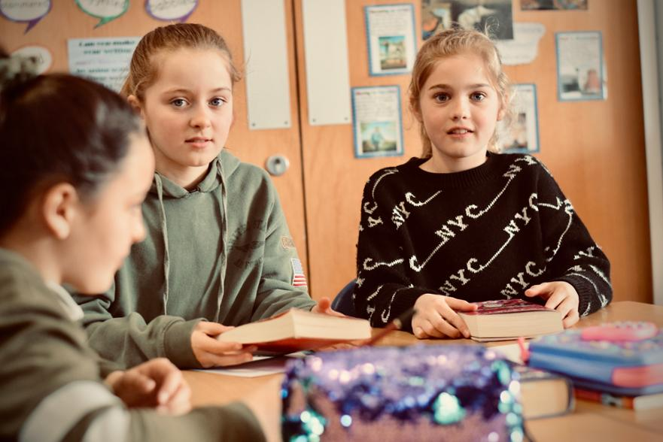



Tel: 01964 527422 Email: aldbrough.primary@eastriding.gov.uk

Twitter @AldbroughSchool



Welcome to Aldbrough Primary School.
The forms in this pack are for school administration use. If you are applying for a school place for your child please contact the East Riding of Yorkshire Council Admissions Team via the following link or ring 01482 393939 and ask for School Admissions. The school requires these forms when you have a formal offer of a place from the East Riding of Yorkshire Councils Admissions Team.

https://www.eastriding.gov.uk/learning/schools-colleges-and-academies/schools-and-school-places/school-admissions-and-catchment-finder/school-places-and-admissions/

Nursery pupils are offered a place the term after their third birthday. Applications for the Nursery are via the school only. Parent/carers are not required to contact the LEA Admissions Team.

You may fill in a form at any point before your child’s third birthday. You will be contacted prior to the term your child would be eligible to begin attending in the Foundation Stage Unit. You may access this place at any stage up to the date your child is due to start mainstream school. New starters are usually offered a place at the beginning of a term. If all places are taken and the unit is oversubscribed places will be offered in date of birth order or other emergency reasons as advised by the LEA.

Privacy Notice (How we use pupil information)
Aldbrough Primary School is the Data Controller for the use of personal data in this privacy notice

The categories of pupil information that we process include:
- personal identifiers and contacts (i.e. name, unique pupil number, contact details and address)
- characteristics (such as ethnicity, language, and free school meal eligibility)
- safeguarding information (such as court orders and professional involvement)
- special educational needs (including the needs and ranking)
- medical and administration (such as doctors information, child health, dental health, allergies, medication and dietary requirements)
- attendance (such as sessions attended, number of absences, absence reasons and any previous schools attended)
- assessment and attainment (such as key stage 1 and phonics results)
- behavioural information (such as exclusions and any relevant alternative provision put in place)
- trips and activities
- catering and free school meal management
This list is not exhaustive.

Why we collect and use pupil information
The personal data collected is essential for the school to fulfil their official functions and meet legal requirements.
We collect and use pupil information, for the following purposes:
- to support pupil learning
- to monitor and report on pupil attainment progress
- to provide appropriate pastoral care
- to assess the quality of our services
- to keep children safe (food allergies, or emergency contact details)
- to meet the statutory duties placed upon us by the Department for Education
Under the General Data Protection Regulation (GDPR), the lawful bases we rely on for processing pupil information are:

Collecting pupil information
We collect pupil information via registration forms, Common Transfer (CTF) or secure file transfer from previous school.
Pupil data is essential for the schools’ operational use. Whilst the majority of pupil information you provide to us is mandatory, some of it is requested on a voluntary basis. In order to comply with the data protection legislation, we will inform you at the point of collection, whether you are required to provide certain pupil information to us or if you have a choice in this and we will tell you what you need to do if you do not want to share this information with us.

Storing pupil data
We hold pupil data securely for the set amount of time shown in our data retention schedule. For more information on our data retention schedule and how we keep your data safe, please visit our website and LEA Policies.

Who we share pupil information with
We routinely share pupil information with:
- other schools
- local authorities
- youth support services (pupils aged 13+)
- the Department for Education (DfE)

Department for Education
The Department for Education (DfE) collects personal data from educational settings and local authorities via various statutory data collections. We are required to share information about our pupils with the Department for Education (DfE) either directly or via our local authority for the purpose of those data collections, under:
School Census
section 3 of The Education (Information About Individual Pupils) (England) Regulations 2013.
All data is transferred securely and held by DfE under a combination of software and hardware controls, which meet the current government security policy framework.
For more information, please see ‘How Government uses your data’ section.
Local Authorities
We may be required to share information about our pupils with the local authority to ensure that they can conduct their statutory duties under
- the Schools Admission Code, including conducting Fair Access Panels.

Requesting access to your personal data
Under GDPR, parents and pupils have the right to request access to information about them that we hold. To make a request for your personal information, or be given access to your child’s educational record, contact the Data Protection Officer Z Harrison, Headteacher.
Depending on the lawful basis above, you may also have the right to:
- object to processing of personal data that is likely to cause, or is causing, damage or distress
- prevent processing for the purpose of direct marketing
- object to decisions being taken by automated means
- in certain circumstances, have inaccurate personal data rectified, blocked, erased or destroyed; and
- a right to seek redress, either through the ICO, or through the courts
If you have a concern about the way we are collecting or using your personal data, you should raise your concern with us in the first instance or directly to the Information Commissioner’s Office at https://ico.org.uk/concerns/
For further information on how to request access to personal information held centrally by DfE, please see the ‘How Government uses your data’ section of this notice.

Last updated
We may need to update this privacy notice periodically so we recommend that you revisit this information from time to time.

Contact
If you would like to discuss anything in this privacy notice, please contact The Data Protection Officer at aldbrough.primary@eastriding.gov.uk

How Government uses your data
The pupil data that we lawfully share with the DfE through data collections:
- underpins school funding, which is calculated based upon the numbers of children and their characteristics in each school.
- informs ‘short term’ education policy monitoring and school accountability and intervention (for example, school GCSE results or Pupil Progress measures).
- supports ‘longer term’ research and monitoring of educational policy (for example how certain subject choices go on to affect education or earnings beyond school)

Data collection requirements
To find out more about the data collection requirements placed on us by the Department for Education (for example; via the school census) go to https://www.gov.uk/education/data-collection-and-censuses-for-schools

The National Pupil Database (NPD)
Much of the data about pupils in England goes on to be held in the National Pupil Database (NPD).
The NPD is owned and managed by the Department for Education and contains information about pupils in schools in England. It provides invaluable evidence on educational performance to inform independent research, as well as studies commissioned by the department.
It is held in electronic format for statistical purposes. This information is securely collected from a range of sources including schools, local authorities and awarding bodies.
To find out more about the NPD, go to https://www.gov.uk/government/publications/national-pupil-database-user-guide-and-supporting-information
Sharing by the Department
The law allows the Department to share pupils’ personal data with certain third parties, including:
- schools
- local authorities
- researchers
- organisations connected with promoting the education or wellbeing of children in England
- other government departments and agencies
- organisations fighting or identifying crime
For more information about the Department’s NPD data sharing process, please visit:
https://www.gov.uk/data-protection-how-we-collect-and-share-research-data
Organisations fighting or identifying crime may use their legal powers to contact DfE to request access to individual level information relevant to detecting that crime. Whilst numbers fluctuate slightly over time, DfE typically supplies data on around 600 pupils per year to the Home Office and roughly 1 per year to the Police.
For information about which organisations the Department has provided pupil information, (and for which project) or to access a monthly breakdown of data share volumes with Home Office and the Police please visit the following website:
https://www.gov.uk/government/publications/dfe-external-data-shares
How to find out what personal information DfE hold about you
Under the terms of the Data Protection Act 2018, you are entitled to ask the Department:
- if they are processing your personal data
- for a description of the data they hold about you
- the reasons they’re holding it and any recipient it may be disclosed to
- for a copy of your personal data and any details of its source
If you want to see the personal data held about you by the Department, you should make a ‘subject access request’. Further information on how to do this can be found within the Department’s personal information charter that is published at the address below:
https://www.gov.uk/government/organisations/department-for-education/about/personal-information-charter
To contact DfE: https://www.gov.uk/contact-dfe
 | ALDBROUGH PRIMARY SCHOOL ADMISSION FORM
 | 1. Child’s Details
 | Forename: |  |  |  | Legal Surname:
 | Date of Birth: |  |  |  | If you have received income related benefits in the past six years, or if one parent works for the armed services, or if your child is adopted or looked after, your child may qualify for Pupil Premium Funding. Do you think this may be the case? YES / NO
 | Is the child subject to a Section 8 order? |  | YES / NO
 | 2. Person(s) with Parental Guidance with whom the child is living
 | Full Name: |  | Mr. / Miss / Mrs. / Ms.
 | Full Name: |  | Mr. / Miss / Mrs. / Ms.
 | Marital Status: |  |  |  | Telephone Numbers:
 | Address including POSTCODE: |  | Email:
Workplace: |  |  |  | Telephone Number:
 | 3. Person(s) with Parental Guidance with whom the child is NOT living
 | Full Name: |  | Mr. / Miss / Mrs. / Ms.
 | Full Name: |  | Mr. / Miss / Mrs. / Ms.
 | Marital Status: |  |  |  | Telephone Numbers:
 | Address including POSTCODE:
Workplace: |  |  |  | Telephone Number:
 | 4. Family Doctor
 | Name: |  |  |  | Telephone Number:
 | 5. Other children living in the family
 | Name & Date of Birth: |  |  |  | Name & Date of Birth:
 | Name & Date of Birth: |  |  |  | Name & Date of Birth:

6. Additional Contact Details
Details of someone else who could be contacted in your absence:
7. Signature
Data Protection: | All the information supplied will be held securely. It will be available to staff that require access to it in order to fulfill their professional duties and care of your child. It will be stored electronically and in hard copy. Please refer to the Privacy Notice (How we use pupil information) regarding the use of the data you are providing. Further information can be found in the Data Protection Policy on the School’s Website.
Signature: |  | Date:

ALDBROUGH PRIMARY SCHOOL ETHNIC BACKGROUND FORM
1. Child’s Details
Forename: |  | Legal Surname:
Date of Birth:
2. Ethnic Background
Guidance: | This information is used to ensure that the school does not discriminate intentionally or unintentionally according to race. Please circle an item on the following list or write an alternative if more appropriate.
Ethnicity: | Asian or Asian British - Indian Asian or Asian British - Pakistani Asian or Asian British - Bangladeshi Any other Asian background Black or Black British - Caribbean Black or Black British- African Black or Black British - any other background  Chinese  Mixed White & Black Caribbean Mixed White & Black African  Mixed White & Asian Mixed- any other mixed background White  White- British English White - British Scottish  White- British Welsh White - British Irish White - Irish  White - Traveller of Irish heritage White - Romany or Gypsy White - any other white background  Any other ethnic group:  Please record the child’s first language  Please record the language mainly spoken at home  Please record the religion of the child if applicable  Please record the child’s nationality  Please record the child’s country of birth
Signature |  | Date
3. Data Protection
Statement: | All the information supplied will be held securely. It will be available to staff that require access to it in order to fulfill their professional duties and care of your child. It will be stored electronically and in hard copy. Please refer to the Privacy Notice (How we use pupil information) regarding the use of the data you are providing. Further information can be found in the Data Protection Policy on the School’s Website.

ALDBROUGH PRIMARY SCHOOL CONFIDENTIAL MEDICAL FORM
1. Child’s Details
Forename: |  | Surname:
Date of Birth:
2. Parent / Carer Details
Full Name: | Mr / Miss / Mrs / Ms
Telephone Number:
Address:
3. Family Doctor
Name:
Address:
4. Medical History
Has your child ever had: | Asthma / Persistent Cough? EXTRA FORM WILL BE SENT Yes No  Hay Fever? Yes No  Eczema? Yes No  Other skin problems? Yes No  Diabetes? EXTRA FORM WILL BE SENT Yes No  Kidney problems? Yes No  Faints, fits or funny turns? Yes No  Epilepsy? EXTRA FORM WILL BE SENT Yes No  Heart problems? Yes No  Recurrent earache or discharging ear? Yes No  Physical disability? Yes No
Has your child had any serious illness, injury, operation or been admitted to hospital? | Yes No | Please give details, including when:
Is your child unable to eat anything for religious reasons | Yes No | Please give details: also please indicate if vegetarian/vegan

Is your child allergic to any food? | Yes No | Please give details:
Is your child allergic to anything else? | Yes No | Please give details:

4. Signature
Data Protection: | All the information supplied will be held securely. It will be available to staff that require access to it in order to fulfill their professional duties and care of your child. It will be stored electronically and in hard copy. Please refer to the Privacy Notice (How we use pupil information) regarding the use of the data you are providing. Further information can be found in the Data Protection Policy on the School’s Website.
Signature: |  | Date:

Space for any additional information you may wish to provide

SCHOOL USE
Received On: |  | Action Required:
Filed in Medical Register: |  | Listed on Confidential List in class register:
Signed: |  | Date:

ALDBROUGH PRIMARY SCHOOL TRANSFER FORM
1. Child’s Details
Forename: |  | Surname:
Date of Birth:
2. Previous School
Name:
Head Teacher:
Address:
Postcode:
Telephone:
Date Started: |  | Date Left:
3. Other Schools
Please list any other schools attended:
4. Signature
Data Protection: | All the information supplied will be held securely. It will be available to staff that require access to it in order to fulfill their professional duties and care of your child. It will be stored electronically and in hard copy. Please refer to the Privacy Notice (How we use pupil information) regarding the use of the data you are providing. Further information can be found in the Data Protection Policy on the School’s Website.
Signature: |  | Date:

ALDBROUGH PRIMARY SCHOOL MEDIA PROTOCOL FORM
1. Child’s Details
Forename: |  | Surname:
Date of Birth:
2. School Website & Twitter Feed
Pupils' work will be published accompanied by a child's first name only and year group. Children are photographed engaging in school activities, only first names and year group may accompany a photograph.
I accept ☐ I reject ☐
3. TV & Radio
TV cameras may be allowed to film generally in school in circumstances when it is in the school’s and pupils’ interests. Pupils will not be filmed as individuals without parental permission.

I am willing for my child(ren) to be interviewed:

I accept ☐ I reject ☐
4. Photographs
Most children and parents like to see photographs of pupils in the paper. In view of this we will continue to invite the press to take photographs of pupils in connection with their work at school. First name and ages may be included, but Last name and addresses will not:

I accept ☐ I reject ☐
5. Signature
Advice: | I believe the above is a sensible response and a balanced approach to ensuring the work and successes of the pupils, and the school can be celebrated whilst maintaining a balanced view on security and privacy. The information provided on this form will be recorded on a spreadsheet but not processed in any other way.

Data Protection: | All the information supplied will be held securely. It will be available to staff that require access to it in order to fulfill their professional duties and care of your child. It will be stored electronically and in hard copy. Please refer to the Privacy Notice (How we use pupil information) regarding the use of the data you are providing. Further information can be found in the Data Protection Policy on the School’s Website.
Signature: |  | Date:

ALDBROUGH PRIMARY SCHOOL RESPONSIBLE INTERNET USE
1. Child’s Details
Forename: |  | Surname:
2. Responsible Internet Use
As part of your child's curriculum and development of Computing skills Aldbrough Primary School is providing supervised access to the Internet. We believe that the use of the World Wide Web and e-mail is worthwhile and is an essential skill for children as they grow up in the modern world. Please read the rules below for responsible internet use and sign and return the consent form. Please be reassured that our school internet provider operates a filtering system that restricts and blocks access to inappropriate materials. This may not be the case at home and should parents wish advice on home use of the internet, they should contact the school.
3. Disclaimer
Whist every endeavour is made to ensure that suitable restrictions are placed on the ability of children to access inappropriate materials, the school cannot be held responsible for the nature or content of materials accessed through the Internet. The school will not be liable for damages arising from your child's use of the Internet facilities. Should you wish to discuss any aspect of Internet use (or see a lesson in operation) please telephone the school to make an appointment.
4. Signature
I have read and understood the school rules for responsible Internet use and give permission for my child(ren) to access the Internet. I understand that the school will take all reasonable precautions to ensure that pupils cannot access inappropriate materials. I understand that the school cannot be held responsible for the nature or content of materials accessed through the internet. I agree that the school is not liable for any damages arising from use of the Internet facilities. The information provided on this form will be recorded on a spreadsheet but not processed in any other way.
Signature: |  | Date:

ALDBROUGH PRIMARY SCHOOL LOCAL AREA VISITS PERMISSION FORM
1. Child’s Details
 |  | Surname:
 |  | Forename
2. PERMISSION FOR LOCAL AREA VISITS
I give permission for my child named above to take part in brief visits into the village with their class or in small groups accompanied by a teacher or other suitably qualified members of Aldbrough Primary School staff. I understand that such visits are in connection with my child’s work within the curriculum.
Signature: |  |  |  | Date:

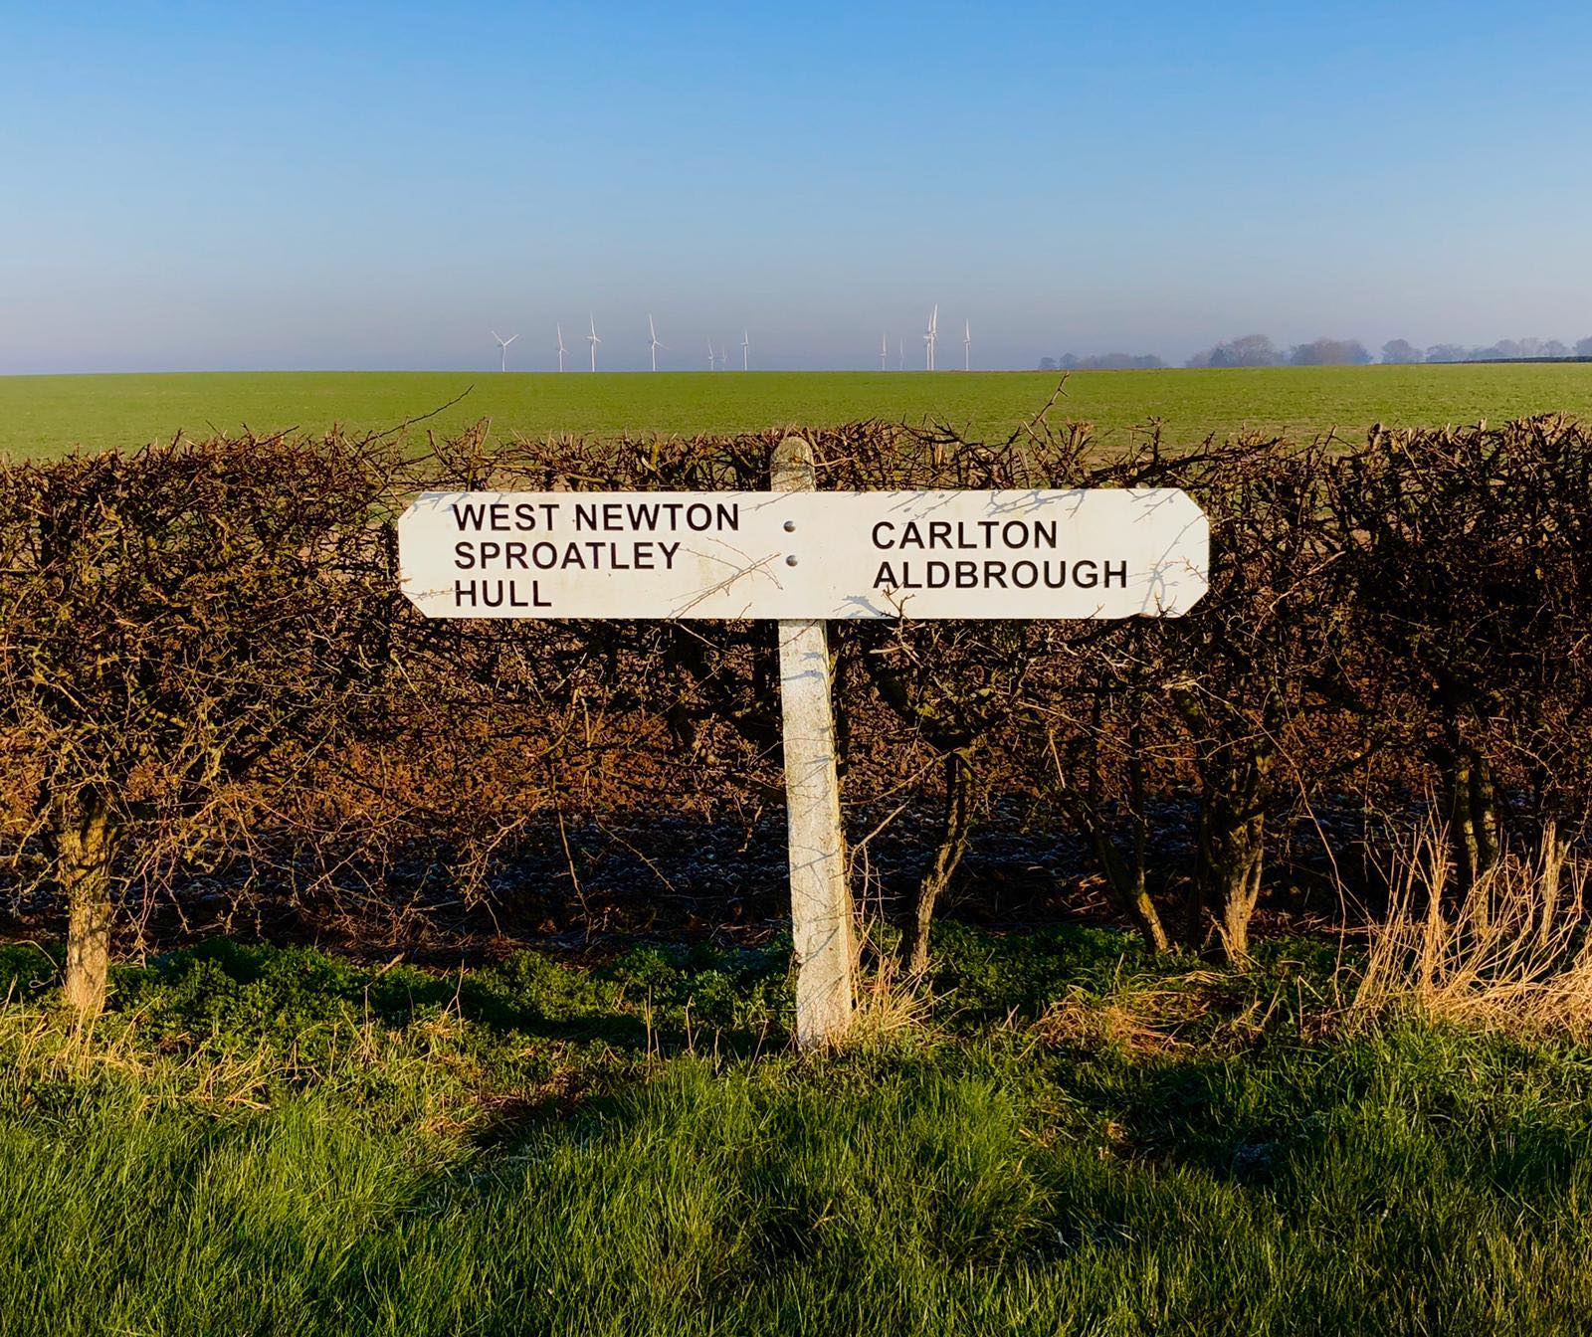

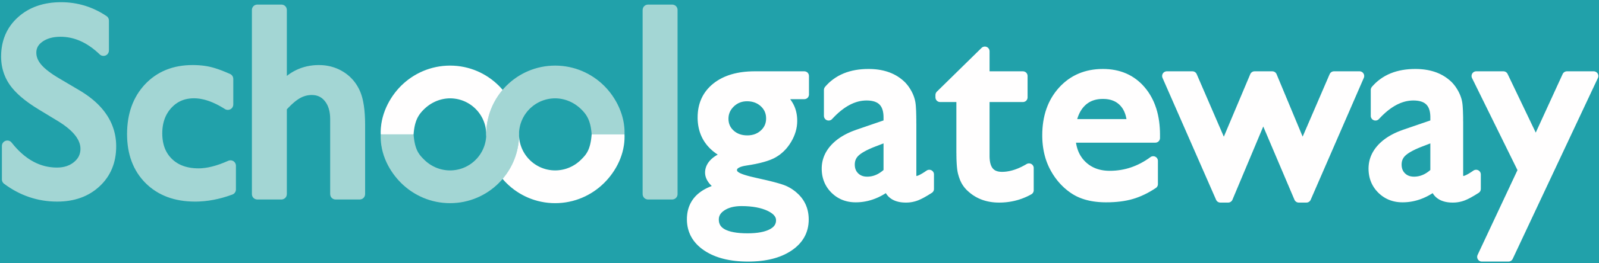
Aldbrough Primary School uses School Gateway parent engagement software, to make sure our parents are as closely involved with their children’s school lives as possible.
School related communication, newsletters, attendance figures, and messages go through School Gateway – it is the central hub of information for our parents – so to stay up to date with what’s going on at school make sure you download the app for free. Just search School Gateway in your App store and download. Simple.
Apple iPhone users, download the app here: schoolgateway.co.uk/iosdownload
Android phone users, download the app here: schoolgateway.co.uk/androiddownload
Your login details will be automatically generated using the contact information Aldbrough Primary School already has, so please make sure the details we hold for you are up to date. You can check and change these details by sending an email to aldbrough.primary@eastriding.gov.uk
If you have any questions or would like some more information, please see the School Gateway site here: https://schoolgateway.co.uk/.
You can also login to the online version of School Gateway via this site if you do not have a smart phone, although we do recommend using the app if possible as it makes it far easier to get hold of parents when we need to.

Remember, download School Gateway to make keeping up-to-date with what’s going on at school effortless. The app is free and saves our school money!

Aldbrough Primary is a cashless premise and provides parents with greater convenience when paying for school trip, clubs and school meals, uniform etc via our secure e-payments solution SIMS Pay; allowing payments online or by cash at PayPoint outlets or Post Office.
Important
Please keep this letter safe as you will need the details within this letter to register your SIMS Pay Account.
Getting Started
We are inviting you to create a new SIMS Pay account for yourself at Aldbrough Primary School.
To access SIMS Pay you will need an account with one of our supported identity providers: SIMS ID, Microsoft, Office 365, Google, Facebook and Twitter. It's likely you already have an account with one of these providers but don't worry if you haven't, Microsoft and Google accounts are free and easy to create.
You can create a Microsoft Account at: https://signup.live.com
You can create a Google Account at: https://accounts.google.com/SignUp
Registering Your Account
- Type the following link into your tablet, PC or smart phone web-browser: https://www.sims-pay.co.uk
- Select Register
- Choose the identity provider you want to use to access SIMS Pay (e.g. Microsoft).
- Enter the Invitation Code which you will receive via an email when your child has attended and registered in their first session.
You must register your account as soon as your child has entered Aldbrough Primary School or Foundation Stage to access all payment options.
Further Information
If you have a question about SIMS Pay you can find out more online or contact a member of the school office staff

ALDBROUGH PRIMARY SCHOOL Travel to and from School
1. Child’s Details
 |  | Surname:
 |  | Forename
2. PUPIL COLLECTION
All children, except children in the foundation stage, will be brought out onto the bottom playground to be collected by a family member.
The teacher or member of staff needs to make sure you are there before sending the child off site. Once the child is released from the teacher they are then the responsibility of the family member
For safeguarding reasons we must know who is allowed to collect your child from school or whether you take the responsibility of your child making their own way home. Please complete the section below.

3 Nominated persons to collect my child
Name |  |  |  | Relationship to child
Signature: |  |  |  | Date:
OR:-
4 Permission for my child to make their own way home from school
I give permission and take full responsibility for my child to make their own way home from school
Signature | Date

FOUNDATION STAGE UNIT (PUPILS AGED 3 AND 4)
Early Years education is available for children 3 years and over, a waiting list is kept in age order. Children are usually offered a place a term after their 3rd birthday. Sessions are offered subject to availability and staffing.
It is a condition of admission that all children must be brought to and from the department by a parent or responsible adult.
Indoor shoes are needed in a named drawstring bag. At this age outdoor learning is a major part of development, please ensure your child has a pair of wellington boots at school, - We will venture out in all weathers.
Milk and fruit is provided free but please let us know if our child cannot take milk or eat fruit for medical reasons.
If you wish to apply for a place please complete the attached form and return it to school. You will then be notified when a place for your child has been allocated.
ALDBROUGH PRIMARY SCHOOL FOUNDATION STAGE PLACEMENT APPLICATION
1. Child’s Details
Full Name
Date of birth
Home address including post code
2 Applicant’s Details
Full Name
Relationship to child
Home address including post code
Email address
Telephone number
3 Declaration and signature
I confirm that I have full parental responsibility for the child named above
Signature: |  |  |  | Date:

The Early Years Pupil Premium
From April 2015, nurseries, schools, childminders and other childcare providers have been able to claim extra funding through the Early Years Pupil Premium to support children’s development, learning and care. We wanted to write to you to explain what the Early Years Pupil Premium is, explain who is eligible for this funding and, importantly, to ask you to fill out the enclosed forms so that we as a provider can claim the extra funding.
National data and research tells us that children eligible for free school meals tend to do less well, for example in 2014, 45% of children eligible for free school meals achieved the expected level at the end of the early years foundation stage compared with 64% of other children. The Early Years Pupil Premium will provide us with extra funding to close this gap.
The Early Years Pupil Premium provides an extra 53 pence per hour for three and four year old children whose parents are in receipt of certain benefits, who were formerly in local authority care or who left care because they were adopted or were subject to a special guardianship or child arrangements order. This means an extra £302 a year for each child taking up the full 570 hours funded entitlement to early education. This additional money could make a significant difference to us.
We can use the extra funding in a way the school chooses to improve the quality of the early years education that we provide for your child. This could include, for example, additional training for our staff on early language, investing in partnership working with our colleagues in the area to further our expertise or supporting our staff in working on specialised areas such as speech and language.
It is well documented that high quality early education can influence how well a child does at both primary and secondary school so we do want to make the most of this additional funding. You may be aware, if you have older children that pupil premium fund has been available for school-age children and it has proved to have given a real boost to the children receiving the funding. We want to do the same for our early years children entitled to this funding.
Therefore we ask that ALL PARENTS/GUARDIANS fill in the attached form. This will allow us to claim the additional Early Years Pupil Premium.
If you have any questions, please contact the school office.

VOLUNTARY FORM – to check eligibility for the EARLY YEARS PUPIL PREMIUM
We would like to collect information about you and your child. This will help us to provide the best education and support for your child by making sure that if your child is eligible for the Early Years Pupil Premium (EYPP) that we receive this funding. We would be grateful if you could complete this form and return it to the school office. Please note that completion of this form is voluntary and non-completion will not affect your child’s eligibility for their place at Aldbrough Primary School Foundation Stage Unit. However, if you do not complete this form, we may not be able to identify whether your child is eligible for the EYPP and we may not receive additional funding to support your child.
ABOUT YOUR CHILD/CHILDREN
Child’s Last Name | Child’s First Name | Child’s Date of Birth |  |  | Name of preschool, nursery, childminder
 |  | D D | M M | Y Y Y Y

PARENT/GUARDIAN DETAILS
 | Parent/Guardian 1 |  |  |  |  |  |  |  |  |  |  |  |  |  |  |  |  |  |  |  | Parent/Guardian 2
Last name
First Name
Date of Birth | D |  |  |  |  |  | M |  |  |  |  |  | Y |  |  |  |  |  |  |  | D |  |  |  |  |  | M |  |  |  |  |  |  | Y
National Insurance Number*
National Asylum Support Service (NASS) Number* |  |  |  | / |  |  |  |  |  |  | / |  |  |  |  |  |  |  |  |  |  |  |  | / |  |  |  |  |  |  | /
Daytime Telephone Number
Mobile Number
Address | Postcode: |  |  |  |  |  |  |  |  |  |  |  |  |  |  |  |  |  |  |  | Postcode:
* Complete as appropriate

FAMILY INCOME AND BENEFIT DETAILS
Is your joint family income over £16,190 per year? (Please place an X in the appropriate box). (This includes those who have parental rights for the child/children named on this form.)
Yes No
If you have ticked yes, you do not need to complete the rest of this section.

If you ticked no, please place an X in this box if you are in receipt of any of the benefits listed below:
Income Support
Income-based Jobseekers Allowance
Income-related Employment and Support Allowance
Universal Credit.
Support from NASS (National Asylum Support Service) under part 6 of the Immigration and Asylum Act 1999
the guarantee element of State Pension Credit
Child Tax Credit (with no Working Tax Credit) with an annual income of no more than £16,190
Working Tax Credit run-on
Please place an X in this box if you are not sure whether your joint family income is over £16,190, or whether you are in receipt of one of the benefits listed above, but you would
still like us to check whether your child is eligible for the EYPP.

ADOPTED CHILDREN, CHILDREN SUBJECT TO A SPECIAL GUARDIANSHIP ORDER OR A CHILD ARRANGEMENTS ORDER
If your child has left care through adoption, special guardianship or a child arrangements order and you would like your child to attract the early years pupil premium, you should complete the following section and attach a copy of the relevant court order
Has your child been adopted from care?
Yes No
If you have ticked yes in the previous question, have you been granted an adoption order by the courts yet?
Yes No
Did your child leave the local authority’s care under a special guardianship order or a child arrangements order (formally known as a residence order)?
Yes No
How the information in this form will be used
Where you have indicated that you are in receipt of one of the listed welfare benefits or you would like us to check whether your child is eligible for the EYPP,
The information you provide in this form will be used by the council to confirm receipt of one of the listed welfare benefits. They will do this by checking the information you have provided against the work benefit data provided by HMRC and DWP. We would like your consent to request the council to make this check.
The council will then confirm whether your child is eligible for the EYPP (but will not notify us of which benefits you are receiving). You are free to withdraw your consent so that your details are not used in future. Whether you provide your details or not will not affect any of the welfare benefits you may be entitled to. The data you provide may also be used to ensure accuracy of records across the local authority and to prevent fraud.

Children who have been adopted from care or are subject to a special guardianship order or a child arrangements order.
Eligibility will be based on your declaration that your child was formally a looked after child and on the evidence of their status e.g. a copy of the relevant order. The local authority will decide whether your child’s nursery, childminder or pre-school is eligible for extra funds through the early years pupil premium. This form and a copy of the relevant order should be returned either to your local authority or your child’s nursery or childminder to enable funding to be allocated. If you decide to return this information to the local authority, please ask your child’s nursery/childminder for the most appropriate address.
DECLARATION
The information I have given on this form is complete and accurate. I understand that my personal information is held securely and will be used only for local authority purposes.
I agree to the local authority using this information to enable my child’s preschool/Nursery/school/childminder to claim the early years pupil premium for my child
Signature of parent/guardian: …………………
Date:……………………….
About this form
All early years providers who deliver Government funded early education can claim the early years pupil premium for three and four year old children whose parents are in receipt of one or more of the following benefits:
- Income Support
- Income-based Jobseekers Allowance
- Universal Credit
- Income-related Employment and Support Allowance
- Support under Part VI of the Immigration and Asylum Act 1999
- the guaranteed element of State Pension Credit
- Child Tax Credit (provided you’re not also entitled to Working Tax Credit and have an annual gross income of no more than £16,190)
- Working Tax Credit run-on

Three and four year olds will also be eligible if:
- they are currently being looked after by a local-authority in England or Wales
- they have left care in England or Wales through an adoption
- they have left care in England or Wales through a special guardianship order or a child arrangement order aid for 4 weeks after you stop qualifying for Working Tax
Completing this form could result in extra funding for your child’s early years provider
Completing this form allows us to check whether your child is eligible for the EYPP which could provide up to an extra £300 for your child’s nursery, pre-school or child minder to fund valuable support like extra training or, resources to help raise the quality of your child’s early education.
We are committed to ensuring that the personal and sensitive information that we hold about you is protected and kept safe and secure, and we have measures in place to prevent the loss, misuse or alteration of your personal information.
We will use the information you provide to check whether your child is eligible for the early years pupil premium.
Thank you for completing this form and helping to make sure your child’s early years provider is as well funded as possible

We want to make sure that we are providing your child with the best education and support we can. Healthy school food has obvious health benefits and can help pupils establish healthy habits for life. Healthy school food can also help to improve pupils’ readiness to learn.
Families who receive certain benefits may be eligible for free school meals. Your child is eligible for free school meals if you’re in receipt of one of the following benefits:
- Universal Credit with an annual net earned income of no more than £7,400.
- Income Support
- Income-based Jobseeker’s Allowance
- Income-related Employment and Support Allowance
- Support under Part 6 of the Immigration and Asylum Act 1999
- The guarantee element of Pension Credit
- Working Tax Credit run-on (paid for the four weeks after you stop qualifying for Working Tax Credit)
- Child Tax Credit (with no Working Tax Credit) with an annual income of no more than £16,190
Registering for free meals could also raise an extra [£1,320 for your child’s primary school]/[£900 for your child’s secondary school], to fund valuable support like extra tuition, additional teaching staff or after school activities.
This additional money is available from central government for every child whose parent is receiving one of the benefits listed above.
To check if your child is eligible, we need information about you and your child. Please complete this form and return to your child’s school.

ABOUT YOUR CHILD/CHILDREN
Child’s Last Name | Child’s First Name | Child’s Date of Birth |  |  | Name of School
 |  | D D | M M | Y Y Y Y

PARENT/GUARDIAN DETAILS
 | Parent/Guardian 1 |  |  |  |  |  |  |  |  |  |  |  |  |  |  |  |  |  |  |  | Parent/Guardian 2
Last name
First Name
Date of Birth | D D |  |  |  |  |  | M M |  |  |  |  |  | Y Y Y Y |  |  |  |  |  |  |  | D D |  |  |  |  |  | M M |  |  |  |  |  |  | Y Y Y Y
National Insurance Number*
National Asylum Support Service (NASS) Number* |  |  |  | / |  |  |  |  |  |  | / |  |  |  |  |  |  |  |  |  |  |  |  | / |  |  |  |  |  |  | /
Daytime Telephone Number
Mobile Number
Address | Postcode: |  |  |  |  |  |  |  |  |  |  |  |  |  |  |  |  |  |  |  | Postcode:

FAMILY INCOME AND BENEFIT DETAILS

If you receive any of the benefits listed below, please place an X in this box.
Income Support
Income-based Jobseekers Allowance
Income-related Employment and Support Allowance
Support from NASS under part 6 of the Immigration and Asylum Act 1999
The guarantee element of Pension Credit
Child Tax Credit (with no Working Tax Credit)
Working Tax Credit run-on
Universal Credit.
Universal Credit
If you are in receipt of Universal Credit, is your net earned family income over £7,400 per year? (Please place an X in the appropriate box).
Your net earned income is your household income after taxes and deductions. It does not include income through Universal Credit or other benefits that you may receive.
Yes No Unsure
Child Tax Credit
If you are in receipt of Child Tax Credit, is your joint gross annual income over £16,190 per year? (Please place an X in the appropriate box).
Your joint gross income is your household income before taxes are taken into account.
Yes No Unsure
If you’re not sure whether you receive one of the listed benefits, or what your household income is, but you would still like us to check whether your child is eligible for free school meals, please place an X in this box.

DECLARATION
The information I have given on this form is complete and accurate. I understand that my personal information is held securely and will be used only for local authority purposes. I agree to the local authority using this information to process my application for free school meals. I also agree to notify the local authority in writing of any change in my family’s financial circumstances as set out in this form.

Signature of parent/guardian: ………………………………………………………….
Date:……………………….
Thank you for completing this form and helping to make sure your child’s school is as well funded as possible.

How the information in this form will be used
The information you provide in this form will be used by the council to confirm receipt of one of the listed welfare benefits. Once this is confirmed, this helps to decide how much money your child’s school will receive each year.
The information will also be used in relation to pupils in year 3 or above to decide whether they are eligible for free school meals.
You only need to complete this form once and it will last for the duration of your child’s time at their current school. You should contact the school or local authority if you have a change in financial circumstances.
We are committed to ensuring that the personal and sensitive information that we hold about you is protected and kept safe and secure, and we have measures in place to prevent the loss, misuse or alteration of your personal information. We will use the information you provide to assess entitlement to free school meals. The information may also be shared with other Council departments to offer benefits and services.

